Objective
Assigning an application icon and creating an installer for the project

Due Date/Time
Must be integrated and added to the remote repository by 9am on the day of the milestone.

Materials
Unity
Click team installer creator

Procedure
Icon
Step One
In unity open the player settings under Edit menu > Project settings > player settings

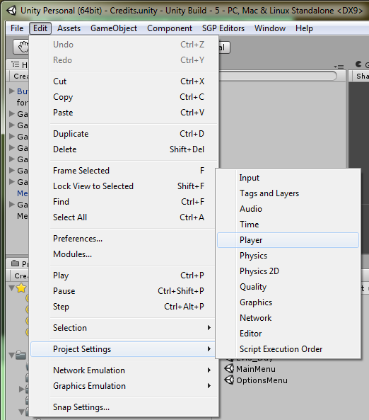

Step Two
On this menu there is a option to set the default icon for the build. Click on the select button under “default icon”

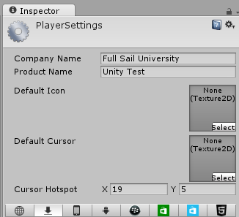

Step Three
A select Texture2D menu will open listing all the texture2D assets in the project. Select the image that is intended to be used as the project’s icon

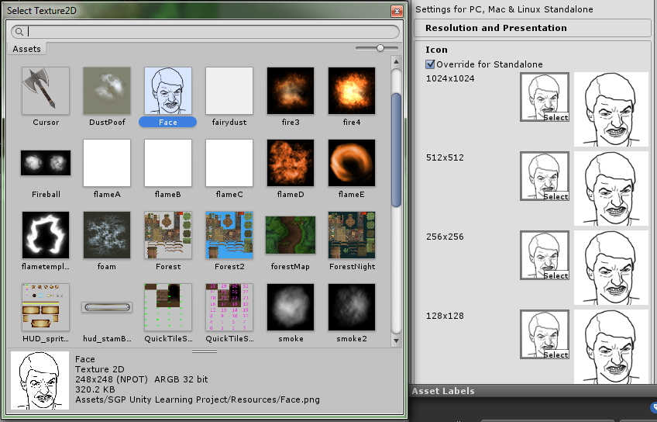

Step Four
Build the project. The next time the project is built it will use the defined texture2D as the icon.

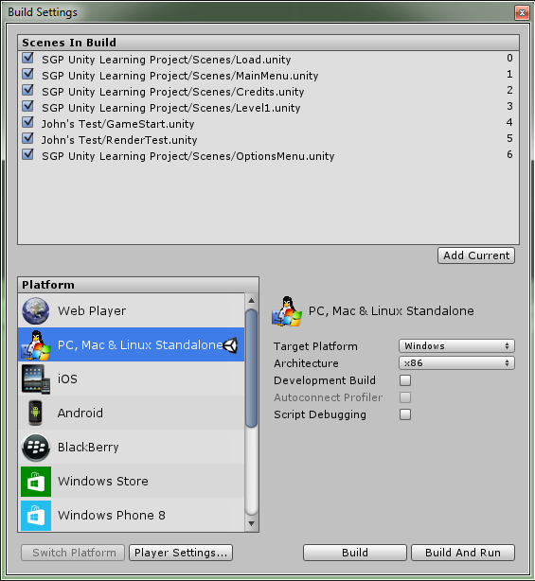

Installer
Step One
There are many ways to create an installer for an application
- Manually creating one in c#/c++ Though effective and allows teams complete control over the installation process it is extremely cost ineffective and wastes time.

- Using Visual Studio 2010 Setup and deployment application. Visual studio’s own installer creator application was discontinued as of visual studio 2012 in favor of install shield

- Using an installer creator application. Many are free to use; even commercially. Clickteam installer creator is recommended for simplicity of use and the free version is free for commercial and non-commercial products

http://www.clickteam.com/install-creator-2

Step Two
Use the wizard to create the installer

The wizard that auto runs on the clickteam installer creator is very thorough and effective at creating installers for applications and prompts the user for all important information. Follow the prompts through the wizard to its completion

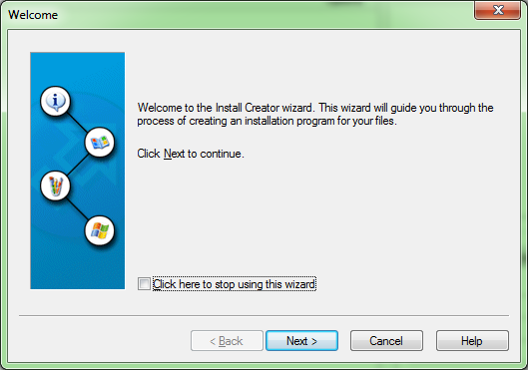

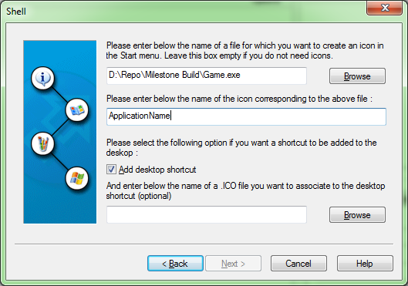

Step Three
Export the installer with an appropriate name when prompted on the last page of the wizard. This step may take a minute or two.

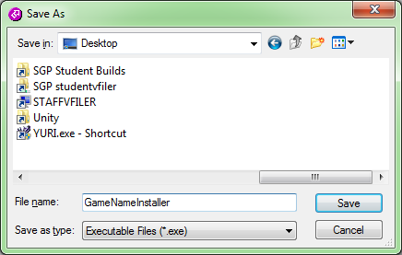

Step Four
To avoid having to recomplete the entire wizard each time there is a new build save the project for the installer so it can regenerate a new installer as the build is updated in the future.

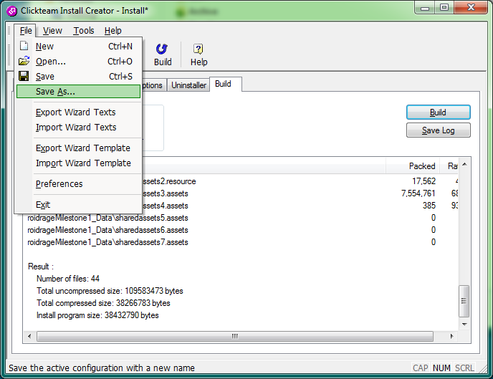

Work submitted:
An installer for the project must be included in the milestone build folder for the beta milestone turn in.

